User story :
“as a Student , I want to view available courses so that I can decide withch course to study”
What does this page need :
- A Heading
- A list of courses
- A link to view courses
ALL COURSES
WEB design
Duration : 4 weeks
View Course
WEB DEVELOPMENT
Duration : 12 weeks
View Course

Create the model
Name , duration for couse

First create a new app with name course app and inside models.py of that app
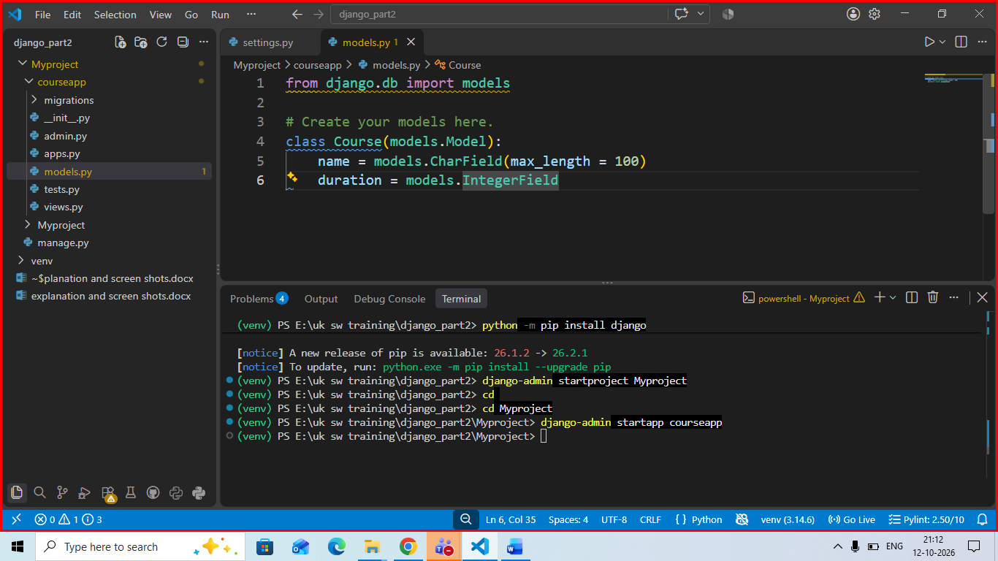
Migrate the model changes to database using migrations command

